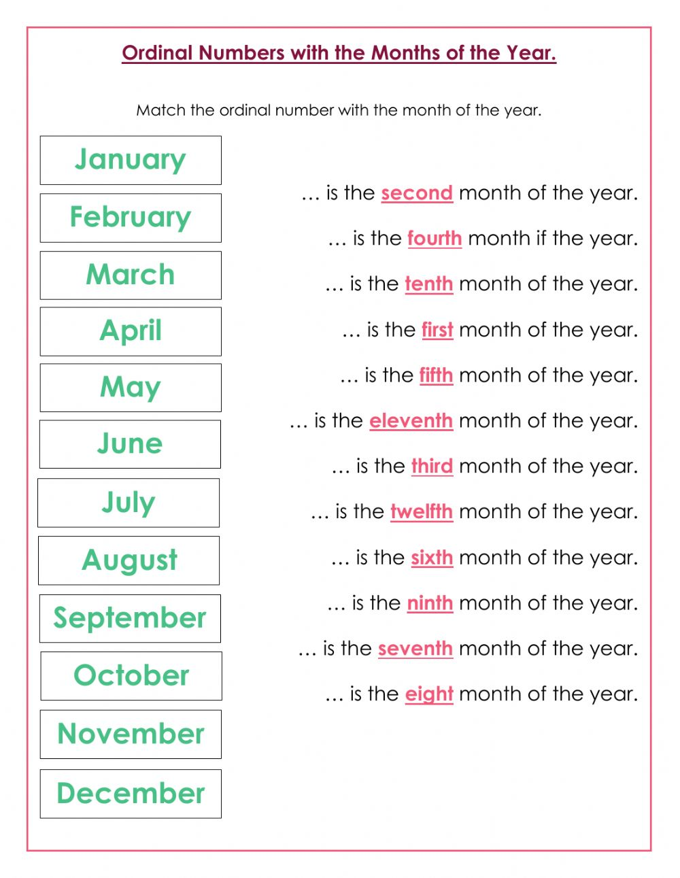

**December**

**November**

**September**

**February**

**August**

**July**

**June**

**March**

**May**

**October**

**April**

**January**